Exercise 13:
Output Screenshot :
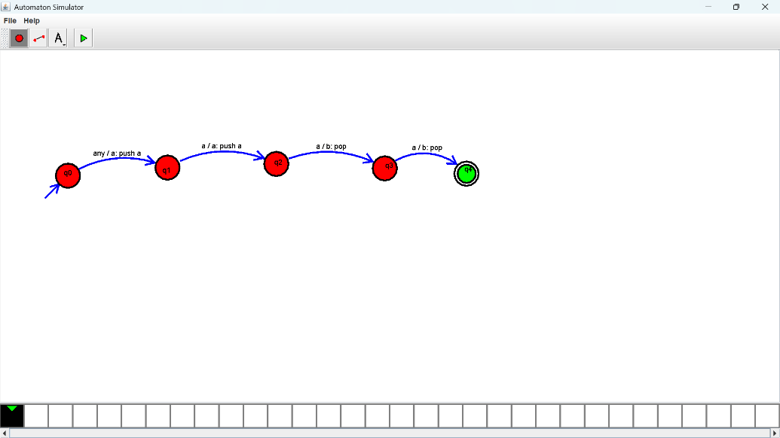

Exercise 14:
Output Screenshoot:

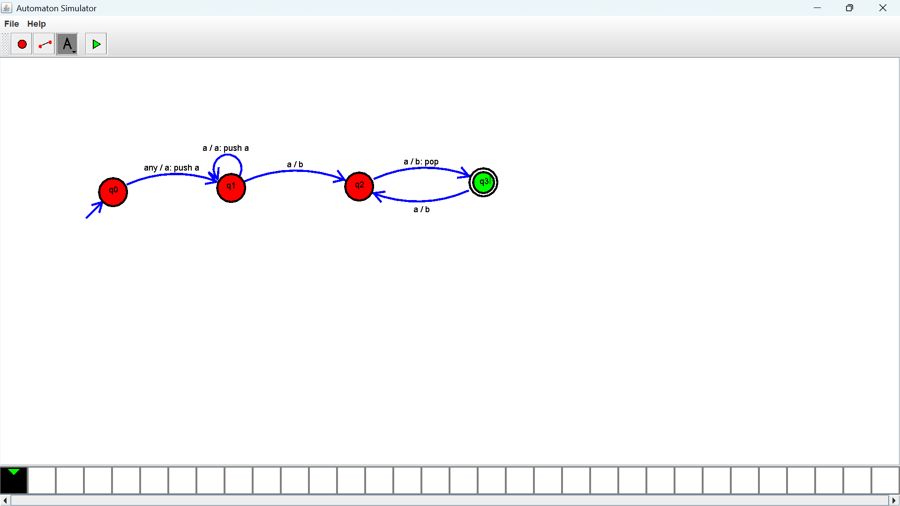

Exercise 15:
Output Screenshot :
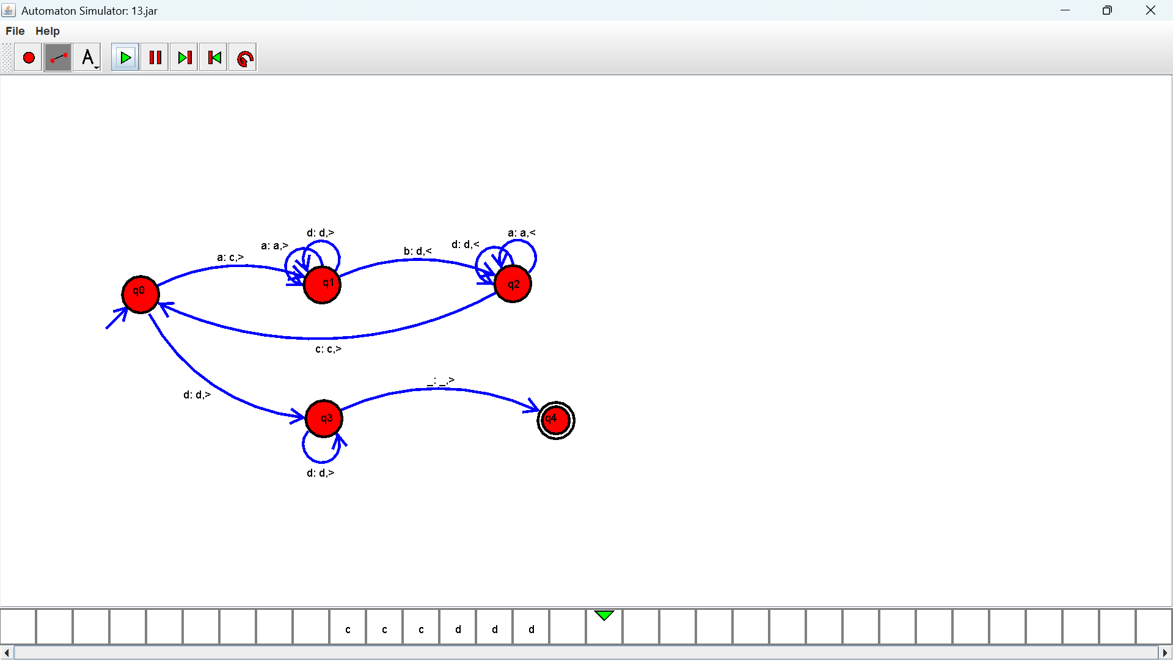

Exercise 16:
Output Screenshot :
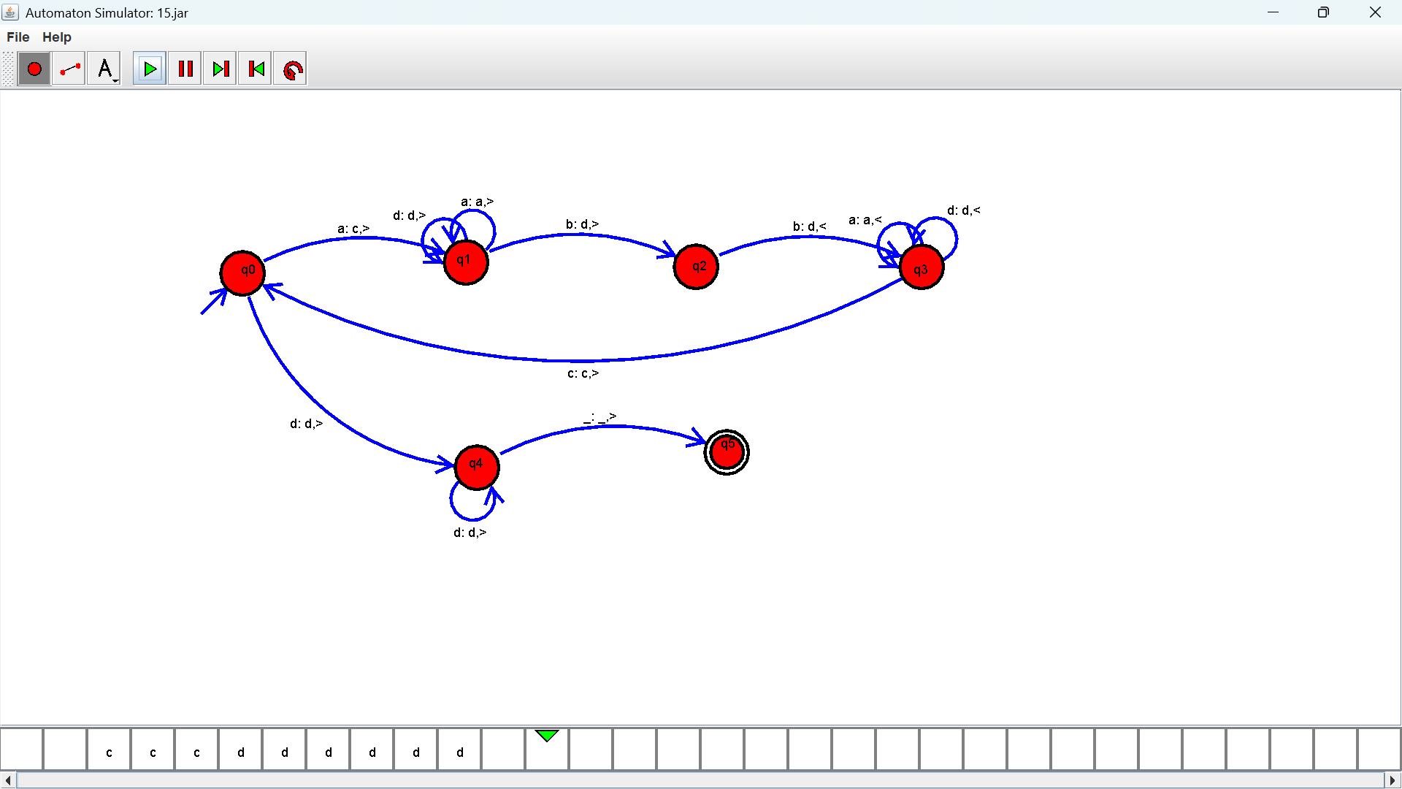

Exercise 17:
Output Screenshot :
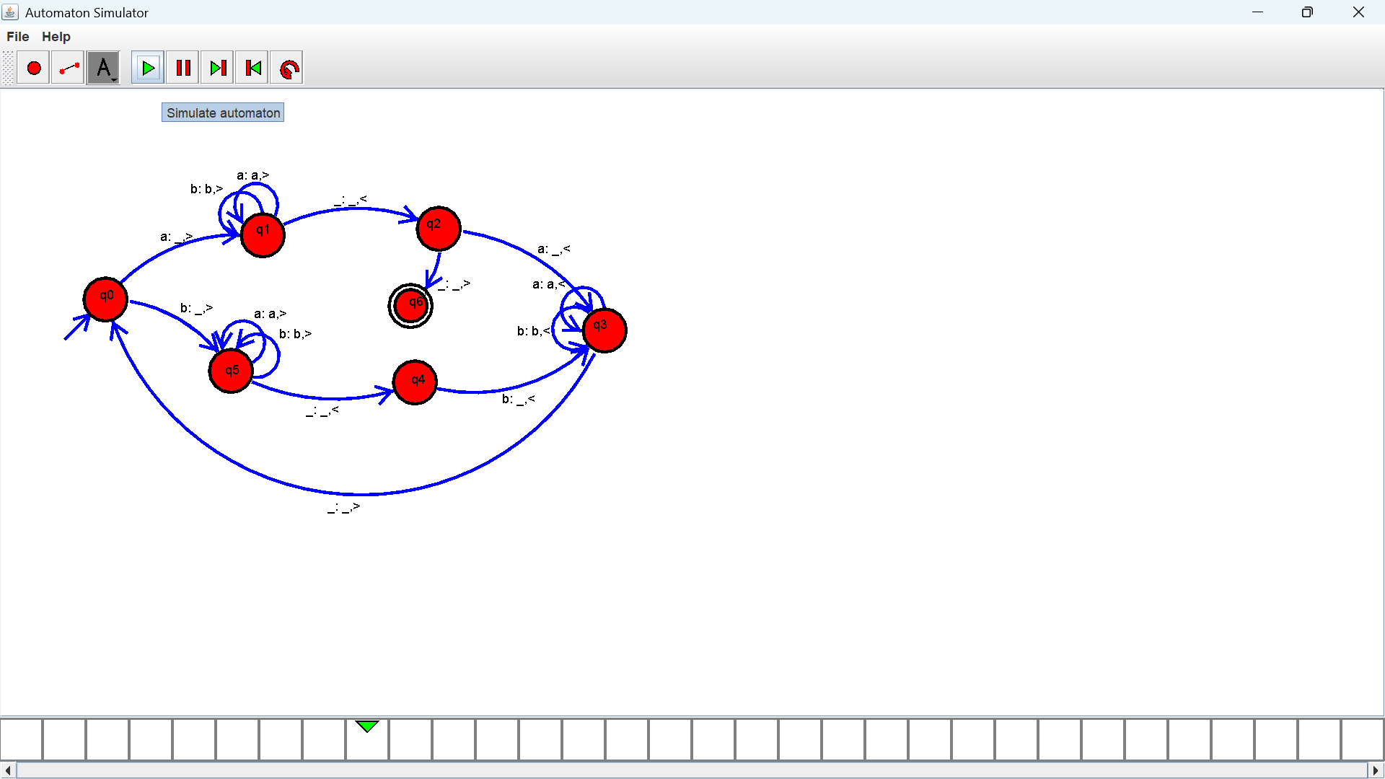

Exercise 18:
Output Screenshot :
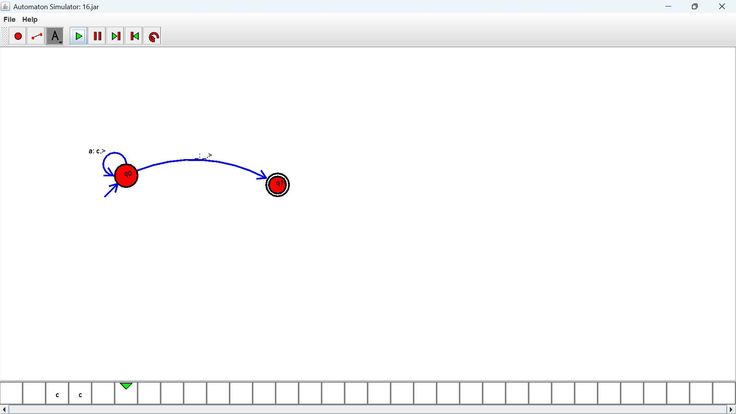

Exercise 19:
Output Screenshot :
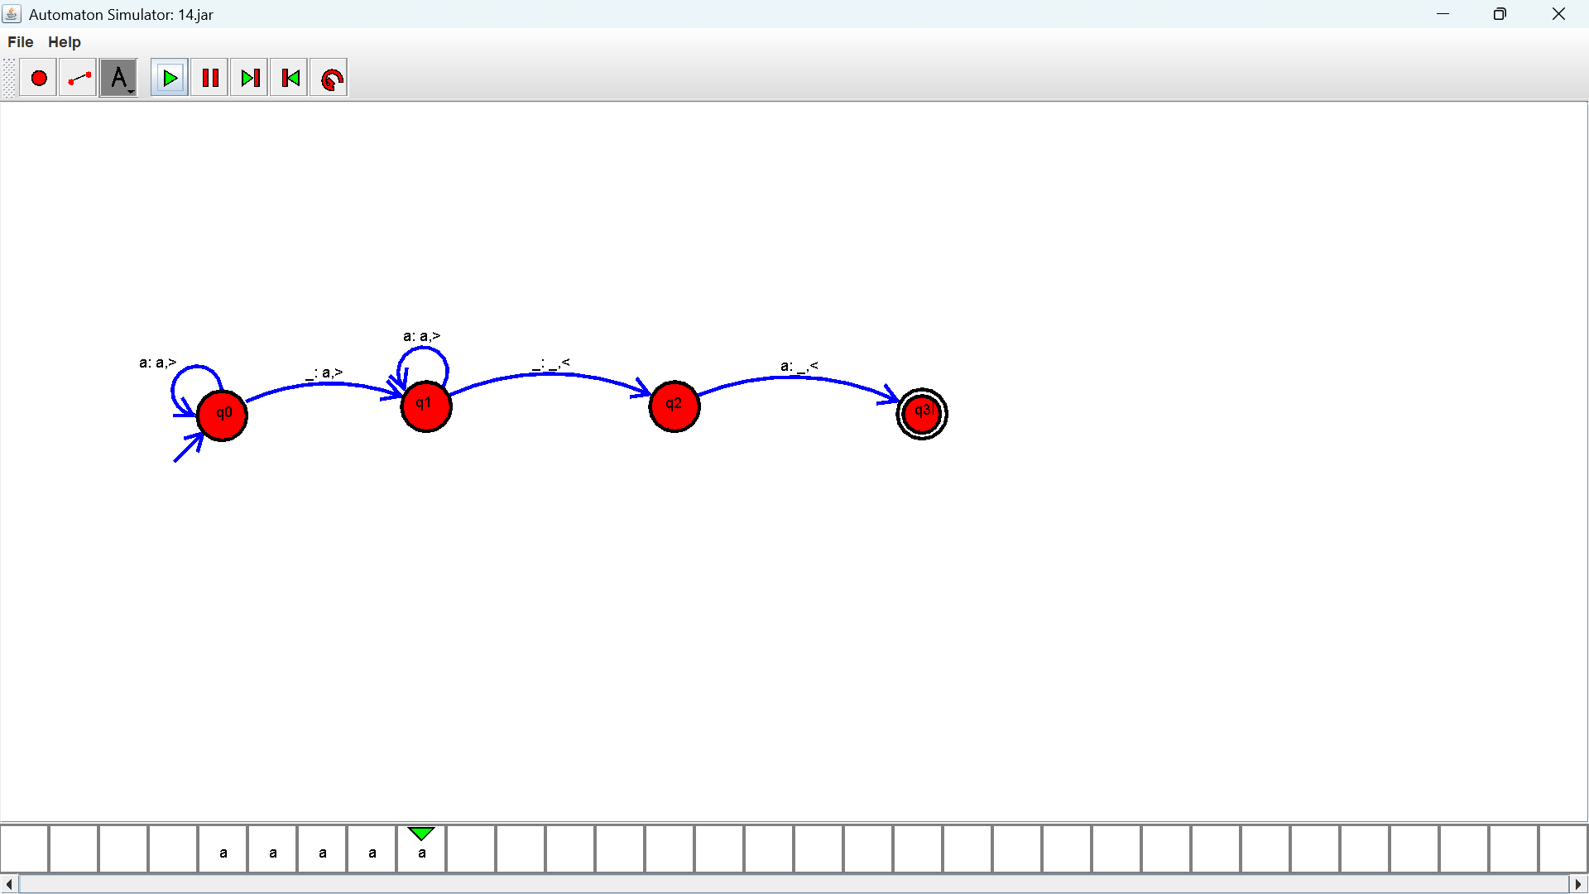
Exercise 20:
Output Screenshot :

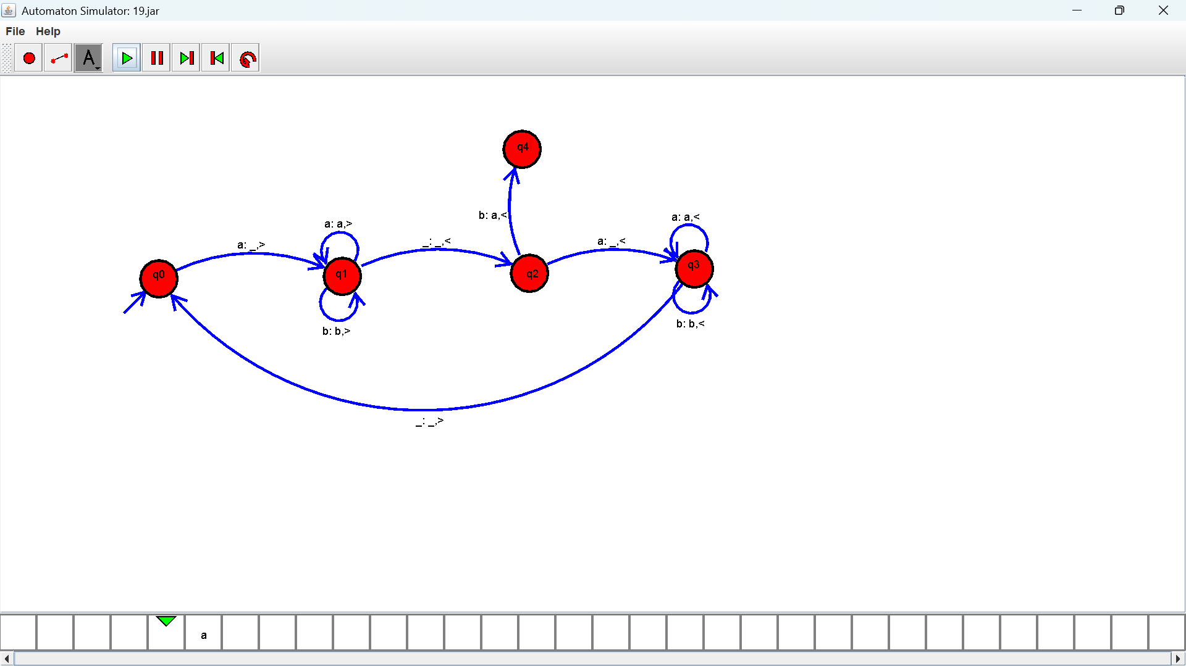

Exercise 21:
Output Screenshot :
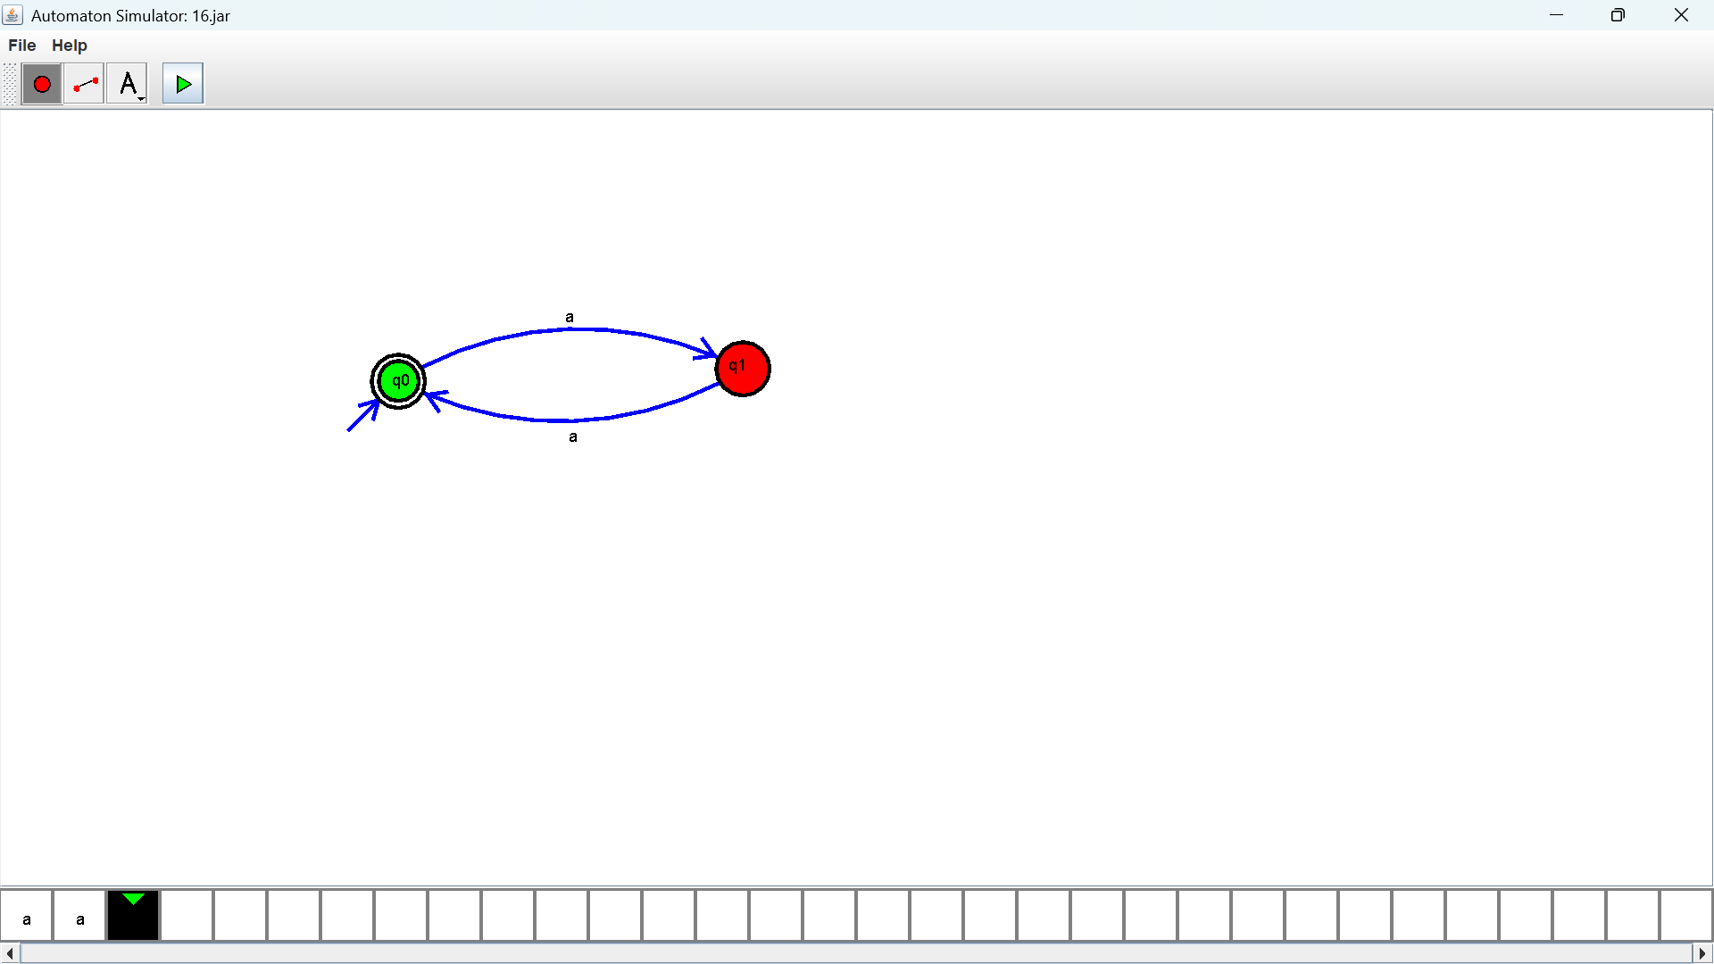

Exercise 22:
Output Screenshot :
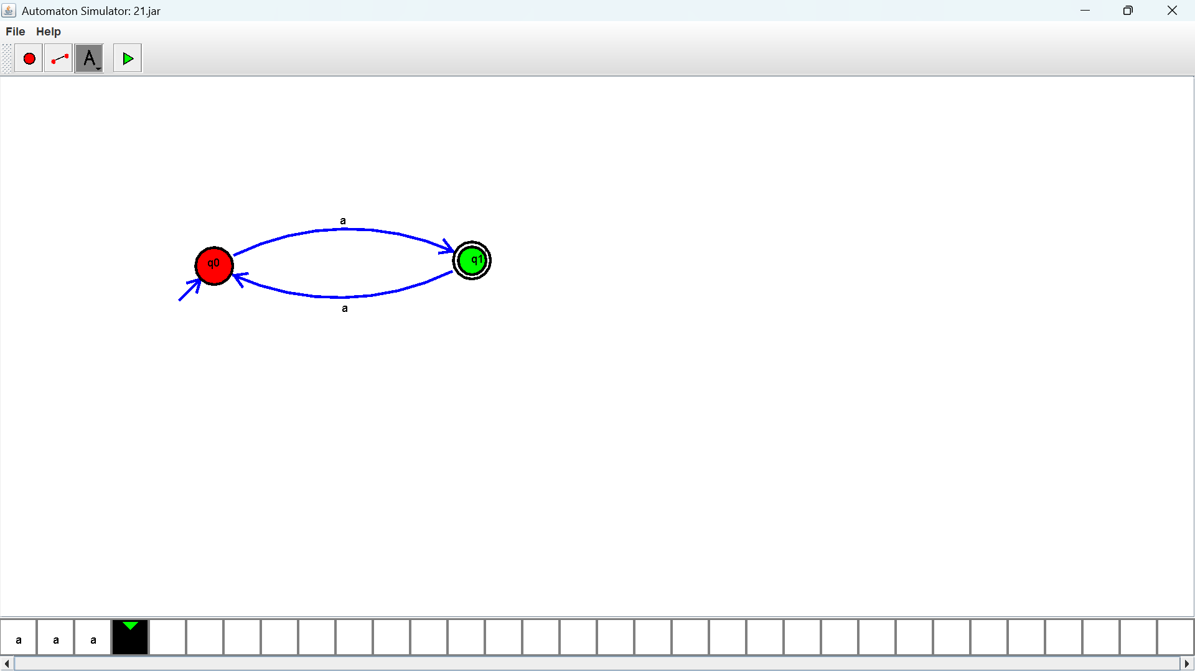

Exercise 23:
Output Screenshot:
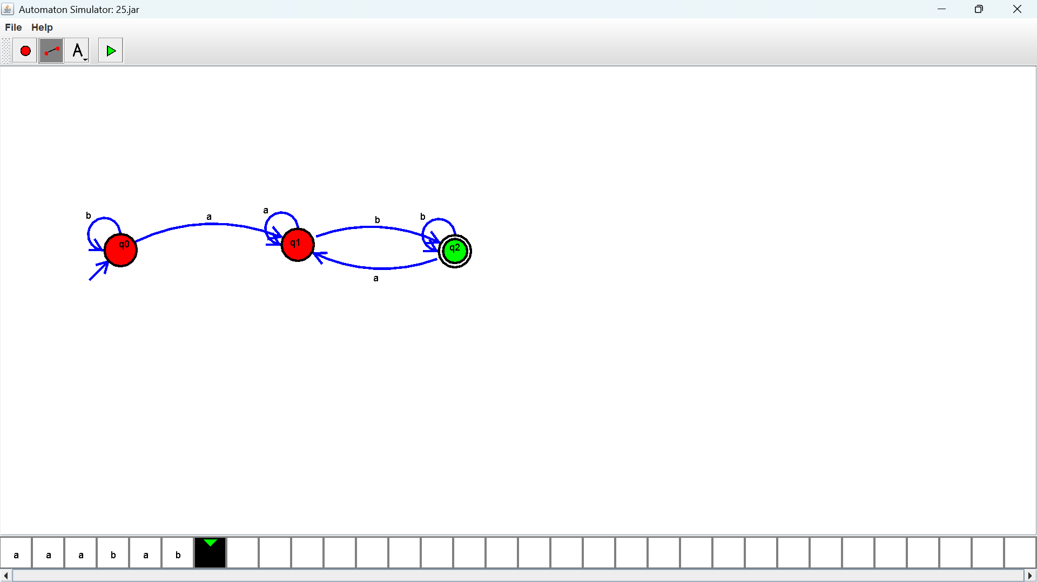

Exercise 24:
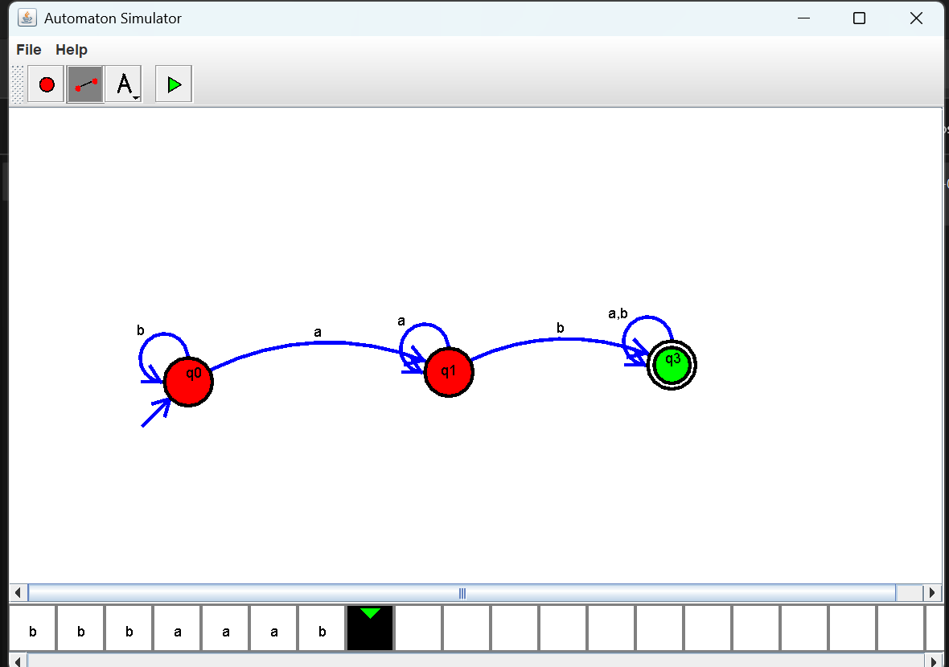
Output Screenshot :

Exercise 25:
Output Screenshot :
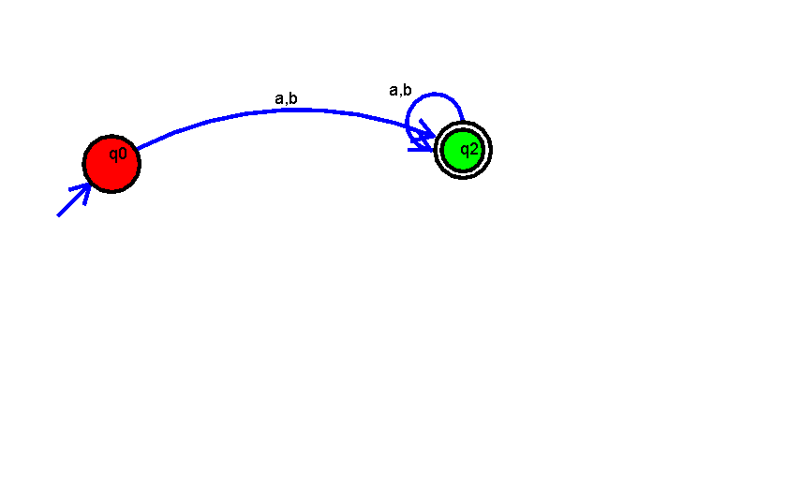

Exercise 26:
Output Screenshot :
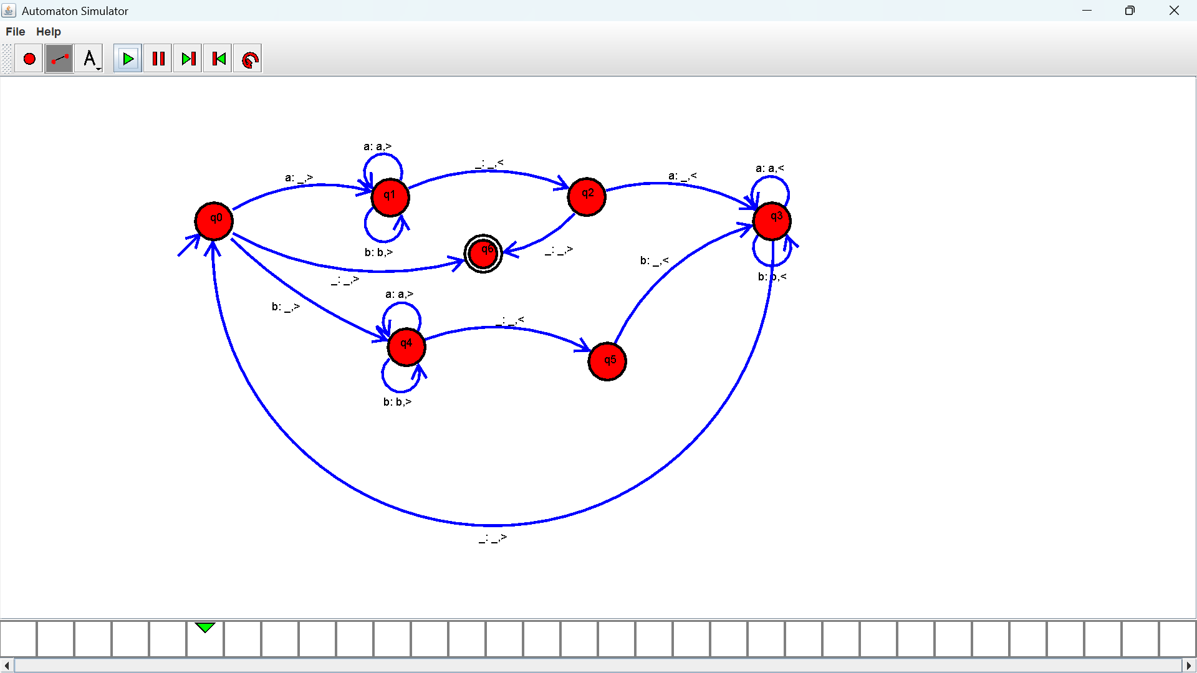

Exercise 27:
Output Screenshot:

Exercise 28:
Output Screenshot:

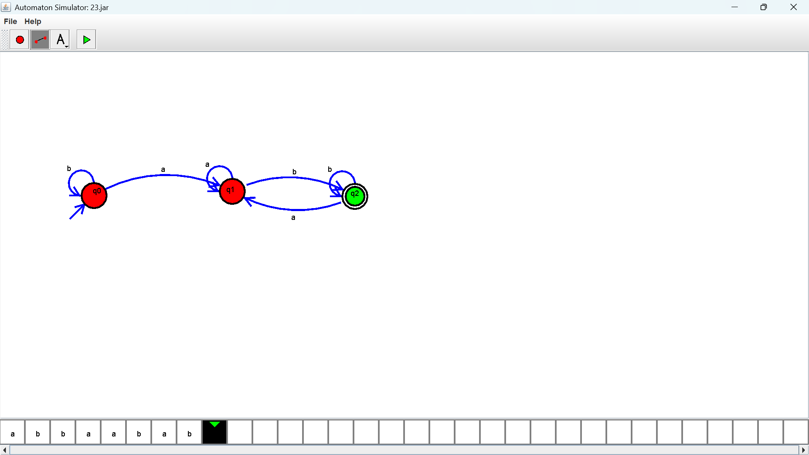

Exercise 29:
Output Screenshot:

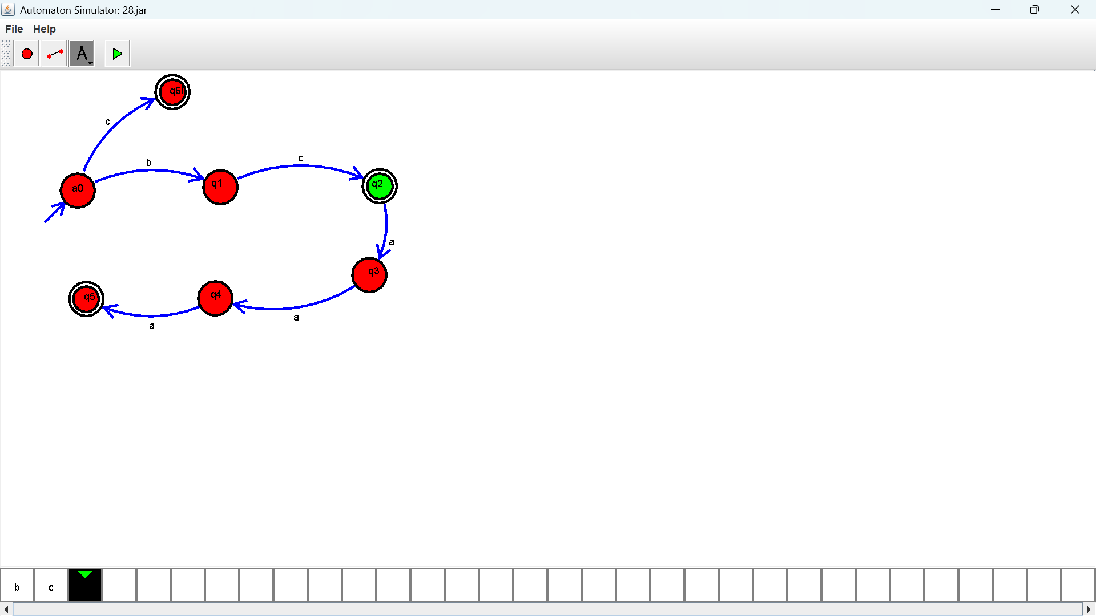

Exercise 30:
Output Screenshot:
